Lab 2 Worksheet Minerals
Name ______ (-2 points if missing)
Date _______
Use your textbook, lab and lecture PowerPoints, and internet as needed to answer all questions in each of the 2 parts. Please explain everything in your own words.
Part 1 Description of your personal sample: Include color, luster, hardness, cleavage or fracture, and special or distinguishing characteristic if any. Non-observable info will take points off.
Mineral Number | Luster | Color | Hardness | Streak | Cleavage or Fracture | Other | Mineral Name
1
2
3
4
5
6
7
8
9
10
11
12
13
14
15

Part 2
- What are 2 simple ways to distinguish calcite and halite?
  - Taste
  - Dissolution
- Between hematite and magnetite, which one has a red/brown streak?
  - Hematite
- List Mohs Hardness scale from softest to hardest
  - Talc
  - Gypsum
  - Calcite
  - Fluorite
  - Apatite
  - Orthoclase
  - Quartz
  - Topaz
  - Corundum
  - Diamond
- Which of following images is potassium feldspar and which is plagioclase feldspar? Explain how you can tell.
  - 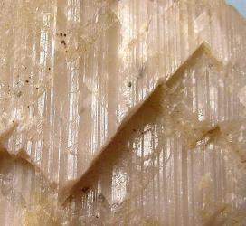 answer: plagioclase feldspar
  - 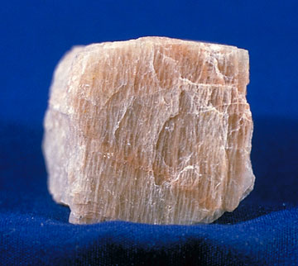 answer: Potassium feldspar

  - Explain: Plagioclase is commonly blocky, with two cleavages as ~90°. Plagioclase is typically more dull white and grey

- Which of your samples in the box left dark smudges on your fingers?
  - Garnet
- Closely examine your three gypsum samples. Of these, which would most likely be used to make drywall, and why?
  - Sulfates; it contains a metal ion such as calcium bonded to sulphate ion.
- In the following image, how many different types of minerals can you spot?
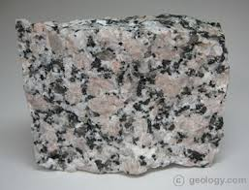
  - 3

- Compare quartz and calcite. What is similar and what is different?
  - Similar: Both are transparent and translucent.
In terms of mineral composition, both minerals crystal structure fall under the trigonal-crystal-shape category.
  - Different: Calcite mineral contains the calcium carbonate mineral while quartz mineral contains the silicon dioxide crystal.
- Identify the cleavage or fracture on the following:
  - 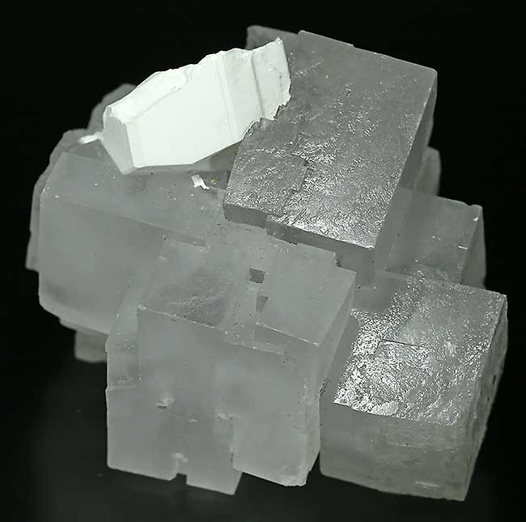 answer: 90 degrees
  - 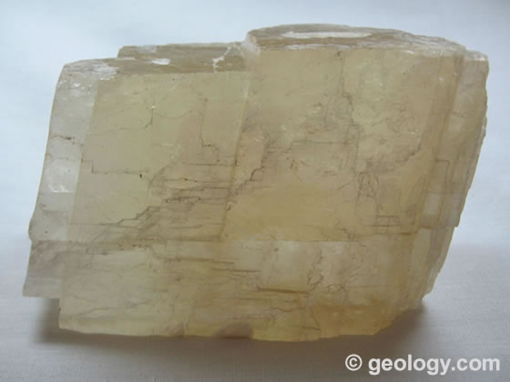 answer: 60/120 degrees
  - 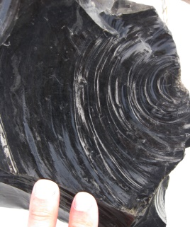 answer: 75degrees

